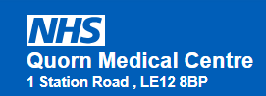

NHS Referrals and Waiting Lists:

- Patients should not be on two NHS waiting lists for the same treatment at the same time. If you would like to be referred to a different hospital or service, your existing referral will need to be cancelled before a new referral can be made.

- Please be aware that receiving a diagnosis does not mean that you will be assessed or treated more quickly. Once a diagnosis has been established, you will continue to be assessed and treated according to the appropriate clinical pathway and the relevant waiting times.

